Lab – Configuring HSRP and GLBP

1. Topology

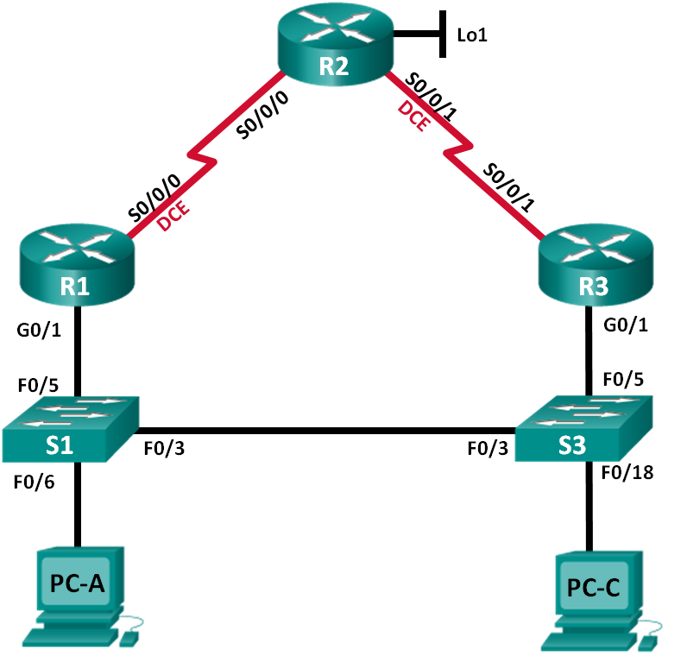

1. Addressing Table

|  |  |  |  |  |
| --- | --- | --- | --- | --- |
| Device | Interface | IP Address | Subnet Mask | Default Gateway |
| R1 | G0/1 | 192.168.1.1 | 255.255.255.0 | N/A |
|  | S0/0/0 (DCE) | 10.1.1.1 | 255.255.255.252 | N/A |
| R2 | S0/0/0 | 10.1.1.2 | 255.255.255.252 | N/A |
|  | S0/0/1 (DCE) | 10.2.2.2 | 255.255.255.252 | N/A |
|  | Lo1 | 209.165.200.225 | 255.255.255.224 | N/A |
| R3 | G0/1 | 192.168.1.3 | 255.255.255.0 | N/A |
|  | S0/0/1 | 10.2.2.1 | 255.255.255.252 | N/A |
| S1 | VLAN 1 | 192.168.1.11 | 255.255.255.0 | 192.168.1.1 |
| S3 | VLAN 1 | 192.168.1.13 | 255.255.255.0 | 192.168.1.3 |
| PC-A | NIC | 192.168.1.31 | 255.255.255.0 | 192.168.1.1 |
| PC-C | NIC | 192.168.1.33 | 255.255.255.0 | 192.168.1.3 |

1. Objectives

Part 1: Build the Network and Verify Connectivity

Part 2: Configure First Hop Redundancy using HSRP

Part 3: Configure First Hop Redundancy using GLBP

1. Background / Scenario

Spanning tree provides loop-free redundancy between switches within your LAN. However, it does not provide redundant default gateways for end-user devices within your network if one of your routers fails. First Hop Redundancy Protocols (FHRPs) provide redundant default gateways for end devices with no end-user configuration necessary.

In this lab, you will configure two FHRPs. In Part 2, you will configure Cisco’s Hot Standby Routing Protocol (HSRP), and in Part 3 you will configure Cisco’s Gateway Load Balancing Protocol (GLBP).

**Note**: The routers used with CCNA hands-on labs are Cisco 1941 Integrated Services Routers (ISRs) with Cisco IOS Release 15.2(4)M3 (universalk9 image). The switches used are Cisco Catalyst 2960s with Cisco IOS Release 15.0(2) (lanbasek9 image). Other routers, switches, and Cisco IOS versions can be used. Depending on the model and Cisco IOS version, the commands available and output produced might vary from what is shown in the labs. Refer to the Router Interface Summary Table at the end of this lab for the correct interface identifiers.

**Note**: Make sure that the routers and switches have been erased and have no startup configurations. If you are unsure, contact your instructor.

1. Required Resources

* 3 Routers (Cisco 1941 with Cisco IOS Release 15.2(4)M3 universal image or comparable)
* 2 Switches (Cisco 2960 with Cisco IOS Release 15.0(2) lanbasek9 image or comparable)
* 2 PCs (Windows 7, Vista, or XP with terminal emulation program, such as Tera Term)
* Console cables to configure the Cisco IOS devices via the console ports
* Ethernet and serial cables as shown in the topology

1. Build the Network and Verify Connectivity

In Part 1, you will set up the network topology and configure basic settings, such as the interface IP addresses, static routing, device access, and passwords.

* 1. Cable the network as shown in the topology.

Attach the devices as shown in the topology diagram, and cable as necessary.

* 1. Configure PC hosts.
  2. Initialize and reload the routers and switches as necessary.
  3. Configure basic settings for each router.
     1. Disable DNS lookup.
     2. Configure the device name as shown in the topology.
     3. Configure IP addresses for the routers as listed in the Addressing Table.
     4. Set clock rate to **128000** for all DCE serial interfaces.
     5. Assign **class** as the encrypted privileged EXEC mode password.
     6. Assign **cisco** for the console and vty password and enable login.
     7. Configure **logging synchronous** to prevent console messages from interrupting command entry.
     8. Copy the running configuration to the startup configuration.
  4. Configure basic settings for each switch.
     1. Disable DNS lookup.
     2. Configure the device name as shown in the topology.
     3. Assign **class** as the encrypted privileged EXEC mode password.
     4. Configure IP addresses for the switches as listed in the Addressing Table.
     5. Configure the default gateway on each switch.
     6. Assign **cisco** for the console and vty password and enable login.
     7. Configure **logging synchronous** to prevent console messages from interrupting command entry.
     8. Copy the running configuration to the startup configuration.
  5. Verify connectivity between PC-A and PC-C.

Ping from PC-A to PC-C. Were the ping results successful? ________________

If the pings are not successful, troubleshoot the basic device configurations before continuing.

**Note**: It may be necessary to disable the PC firewall to successfully ping between PCs.

* 1. Configure routing.
     1. Configure OSPF on the routers in area 0 with process ID of 1. Add all the networks, except 209.165.200.224/27 into the OSPF process.
     2. Configure a default route on R2 using Lo1 as the exit interface to 209.165.200.224/27 network and redistribute this route into the OSPF process.
  2. Verify connectivity.
     1. From PC-A, you should be able to ping every interface on R1, R2, R3, and PC-C. Were all pings successful? ______________

If the pings are not successful, troubleshoot the basic device configurations before continuing.

* + 1. From PC-C, you should be able to ping every interface on R1, R2, R3, and PC-A. Were all pings successful? ______________

If the pings are not successful, troubleshoot the basic device configurations before continuing.

1. Configure First Hop Redundancy Using HSRP

Even though the topology has been designed with some redundancy (two routers and two switches on the same LAN network), both PC-A and PC-C are configured with only one gateway address. PC-A is using R1 and PC-C is using R3. If either of these routers or the interfaces on the routers went down, the PC could lose its connection to the Internet.

In Part 2, you will test how the network behaves both before and after configuring HSRP. To do this, you will determine the path that packets take to the loopback address on R2.

* 1. Determine the path for Internet traffic for PC-A and PC-C.
     1. From a command prompt on PC-A, issue a **tracert** command to the 209.165.200.225 loopback address of R2.

C:\ **tracert 209.165.200.225**

Tracing route to 209.165.200.225 over a maximum of 30 hops

1 1 ms 1 ms 1 ms 192.168.1.1

2 13 ms 13 ms 13 ms 209.165.200.225

Trace complete.

What path did the packets take from PC-A to 209.165.200.225? _________________________________

* + 1. From a command prompt on PC-C, issue a **tracert** command to the 209.165.200.225 loopback address of R2.

What path did the packets take from PC-C to 209.165.200.225? ________________________________

* 1. Start a ping session on PC-A, and break the connection between S1 and R1.
     1. From a command prompt on PC-A, issue a **ping –t** command to the **209.165.200.225** address on R2. Make sure you leave the command prompt window open.

**Note**: The pings continue until you press **Ctrl**+**C**, or until you close the command prompt window.

C:\ **ping –t 209.165.200.225**

Pinging 209.165.200.225 with 32 bytes of data:

Reply from 209.165.200.225: bytes=32 time=9ms TTL=254

Reply from 209.165.200.225: bytes=32 time=9ms TTL=254

Reply from 209.165.200.225: bytes=32 time=9ms TTL=254

Reply from 209.165.200.225: bytes=32 time=9ms TTL=254

Reply from 209.165.200.225: bytes=32 time=9ms TTL=254

Reply from 209.165.200.225: bytes=32 time=9ms TTL=254

Reply from 209.165.200.225: bytes=32 time=9ms TTL=254

Reply from 209.165.200.225: bytes=32 time=9ms TTL=254

Reply from 209.165.200.225: bytes=32 time=9ms TTL=254

Reply from 209.165.200.225: bytes=32 time=9ms TTL=254

Reply from 209.165.200.225: bytes=32 time=9ms TTL=254

Reply from 209.165.200.225: bytes=32 time=9ms TTL=254

Reply from 209.165.200.225: bytes=32 time=9ms TTL=254

<output omitted>

* + 1. As the ping continues, disconnect the Ethernet cable from F0/5 on S1. You can also shut down the S1 F0/5 interface, which creates the same result.

What happened to the ping traffic?

____________________________________________________________________________________

* + 1. Repeat Steps 2a and 2b on PC-C and S3. Disconnect cable from F0/5 on S3.

What were your results?

____________________________________________________________________________________

* + 1. Reconnect the Ethernet cables to F0/5 or enable the F0/5 interface on both S1 and S3, respectively. Re-issue pings to 209.165.200.225 from both PC-A and PC-C to make sure connectivity is re-established.
  1. Configure HSRP on R1 and R3.

In this step, you will configure HSRP and change the default gateway address on PC-A, PC-C, S1, and S2 to the virtual IP address for HSRP. R1 becomes the active router via configuration of the HSRP priority command.

* + 1. Configure HSRP on R1.

R1(config)# **interface g0/1**

R1(config-if)# **standby 1 ip 192.168.1.254**

R1(config-if)# **standby 1 priority 150**

R1(config-if)# **standby 1 preempt**

* + 1. Configure HSRP on R3.

R3(config)# **interface g0/1**

R3(config-if)# **standby 1 ip 192.168.1.254**

* + 1. Verify HSRP by issuing the **show standby** command on R1 and R3.

R1# **show standby**

GigabitEthernet0/1 - Group 1

State is Active

1 state change, last state change 00:02:11

Virtual IP address is 192.168.1.254

Active virtual MAC address is 0000.0c07.ac01

Local virtual MAC address is 0000.0c07.ac01 (v1 default)

Hello time 3 sec, hold time 10 sec

Next hello sent in 0.784 secs

Preemption enabled

Active router is local

Standby router is 192.168.1.3, priority 100 (expires in 9.568 sec)

Priority 150 (configured 150)

Group name is "hsrp-Gi0/1-1" (default)

R3# **show standby**

GigabitEthernet0/1 - Group 1

State is Standby

4 state changes, last state change 00:02:20

Virtual IP address is 192.168.1.254

Active virtual MAC address is 0000.0c07.ac01

Local virtual MAC address is 0000.0c07.ac01 (v1 default)

Hello time 3 sec, hold time 10 sec

Next hello sent in 2.128 secs

Preemption disabled

Active router is 192.168.1.1, priority 150 (expires in 10.592 sec)

Standby router is local

Priority 100 (default 100)

Group name is "hsrp-Gi0/1-1" (default)

Using the output shown above, answer the following questions:

Which router is the active router? _____________________

What is the MAC address for the virtual IP address? ____________________________

What is the IP address and priority of the standby router?

____________________________________________________________________________________

____________________________________________________________________________________

* + 1. Use the **show standby brief** command on R1 and R3 to view an HSRP status summary. Sample output is shown below.

R1# **show standby brief**

P indicates configured to preempt.

|

Interface Grp Pri P State Active Standby Virtual IP

Gi0/1 1 150 P Active local 192.168.1.3 192.168.1.254

R3# **show standby brief**

P indicates configured to preempt.

|

Interface Grp Pri P State Active Standby Virtual IP

Gi0/1 1 100 Standby 192.168.1.1 local 192.168.1.254

* + 1. Change the default gateway address for PC-A, PC-C, S1, and S3. Which address should you use?

____________________________________________________________________________________

* + 1. Verify the new settings. Issue a ping from both PC-A and PC-C to the loopback address of R2. Are the pings successful? __________
  1. Start a ping session on PC-A and break the connection between the switch that is connected to the Active HSRP router (R1).
     1. From a command prompt on PC-A, issue a **ping –t** command to the 209.165.200.225 address on R2. Ensure that you leave the command prompt window open.
     2. As the ping continues, disconnect the Ethernet cable from F0/5 on S1 or shut down the F0/5 interface.

What happened to the ping traffic?

____________________________________________________________________________________

____________________________________________________________________________________

____________________________________________________________________________________

* 1. Verify HSRP settings on R1 and R3.
     1. Issue the **show standby brief** command on R1 and R3.

Which router is the active router? __________________________________

* + 1. Reconnect the cable between the switch and the router or enable interface F0/5.
    2. Disable the HSRP configuration commands on R1 and R3.

R1(config)# **interface g0/1**

R1(config-if)# **no standby 1**

R3(config)# **interface g0/1**

R3(config-if)# **no standby 1**

1. Configure First Hop Redundancy Using GLBP

By default, HSRP does NOT do load balancing. The active router always handles all of the traffic, while the standby router sits unused, unless there is a link failure. This is not an efficient use of resources. GLBP provides nonstop path redundancy for IP by sharing protocol and MAC addresses between redundant gateways. GLBP also allows a group of routers to share the load of the default gateway on a LAN. Configuring GLBP is very similar to HSRP. Load balancing can be done in a variety of ways using GLBP. In this lab, you will use the round-robin method.

* 1. Configure GLBP on R1 and R3.
     1. Configure GLBP on R1.

R1(config)# **interface g0/1**

R1(config-if)# **glbp 1 ip 192.168.1.254**

R1(config-if)# **glbp 1 preempt**

R1(config-if)# **glbp 1 priority 150**

R1(config-if)# **glbp 1 load-balancing round-robin**

* + 1. Configure GLBP on R3.

R3(config)# **interface g0/1**

R3(config-if)# **glbp 1 ip 192.168.1.254**

R3(config-if)# **glbp 1 load-balancing round-robin**

* 1. Verify GLBP on R1 and R3.
     1. Issue the **show glbp brief** command on R1 and R3.

R1# **show glbp brief**

Interface Grp Fwd Pri State Address Active router Standby router

Gi0/1 1 - 150 Active 192.168.1.254 local 192.168.1.3

Gi0/1 1 1 - Active 0007.b400.0101 local -

Gi0/1 1 2 - Listen 0007.b400.0102 192.168.1.3 -

R3# **show glbp brief**

Interface Grp Fwd Pri State Address Active router Standby router

Gi0/1 1 - 100 Standby 192.168.1.254 192.168.1.1 local

Gi0/1 1 1 - Listen 0007.b400.0101 192.168.1.1 -

Gi0/1 1 2 - Active 0007.b400.0102 local -

* 1. Generate traffic from PC-A and PC-C to the R2 loopback interface.
     1. From a command prompt on PC-A, ping the 209.165.200.225 address of R2.

C:\> **ping 209.165.200.225**

* + 1. Issue an **arp –a** command on PC-A. Which MAC address is used for the 192.168.1.254 address?

____________________________________________________________________________________

* + 1. Generate more traffic to the loopback interface of R2. Issue another **arp –a** command. Did the MAC address change for the default gateway address of 192.168.1.254?

____________________________________________________________________________________

As you can see, both R1 and R3 play a role in forwarding traffic to the loopback interface of R2. Neither router remains idle.

* 1. Start a ping session on PC-A, and break the connection between the switch that is connected to R1.
     1. From a command prompt on PC-A, issue a **ping –t** command to the 209.165.200.225 address on R2. Make sure you leave the command prompt window open.
     2. As the ping continues, disconnect the Ethernet cable from F0/5 on S1 or shut down the F0/5 interface.

What happened to the ping traffic?

____________________________________________________________________________________

____________________________________________________________________________________

1. Reflection
   1. Why would there be a need for redundancy in a LAN?

_______________________________________________________________________________________

* 1. If you had a choice, which protocol would you implement in your network, HSRP or GLBP? Explain your choice.

_______________________________________________________________________________________

1. Router Interface Summary Table

|  |  |  |  |  |
| --- | --- | --- | --- | --- |
| Router Interface Summary | | | | |
| Router Model | Ethernet Interface #1 | Ethernet Interface #2 | Serial Interface #1 | Serial Interface #2 |
| 1800 | Fast Ethernet 0/0 (F0/0) | Fast Ethernet 0/1 (F0/1) | Serial 0/0/0 (S0/0/0) | Serial 0/0/1 (S0/0/1) |
| 1900 | Gigabit Ethernet 0/0 (G0/0) | Gigabit Ethernet 0/1 (G0/1) | Serial 0/0/0 (S0/0/0) | Serial 0/0/1 (S0/0/1) |
| 2801 | Fast Ethernet 0/0 (F0/0) | Fast Ethernet 0/1 (F0/1) | Serial 0/1/0 (S0/1/0) | Serial 0/1/1 (S0/1/1) |
| 2811 | Fast Ethernet 0/0 (F0/0) | Fast Ethernet 0/1 (F0/1) | Serial 0/0/0 (S0/0/0) | Serial 0/0/1 (S0/0/1) |
| 2900 | Gigabit Ethernet 0/0 (G0/0) | Gigabit Ethernet 0/1 (G0/1) | Serial 0/0/0 (S0/0/0) | Serial 0/0/1 (S0/0/1) |
| **Note**: To find out how the router is configured, look at the interfaces to identify the type of router and how many interfaces the router has. There is no way to effectively list all the combinations of configurations for each router class. This table includes identifiers for the possible combinations of Ethernet and Serial interfaces in the device. The table does not include any other type of interface, even though a specific router may contain one. An example of this might be an ISDN BRI interface. The string in parenthesis is the legal abbreviation that can be used in Cisco IOS commands to represent the interface. | | | | |